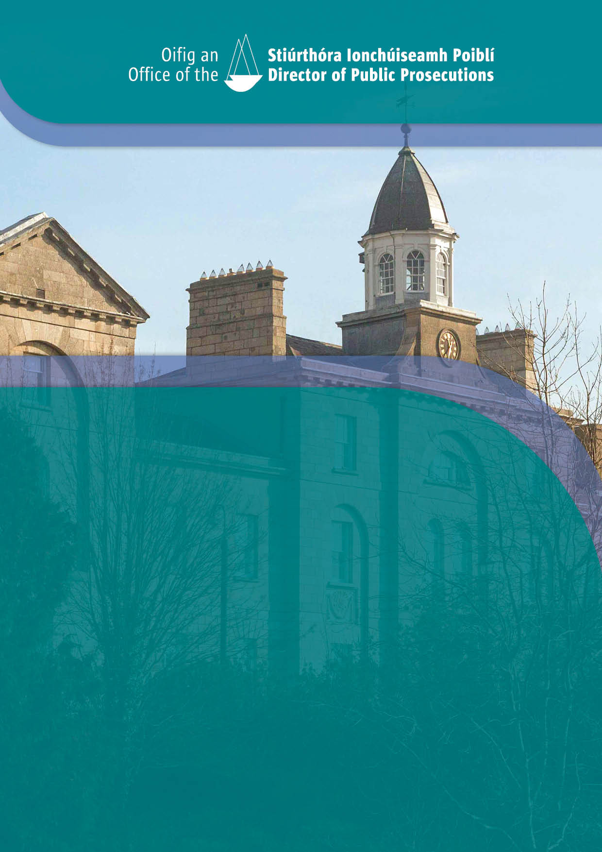

Office of the Director of Public Prosecutions

Gender Pay Gap Report 2024

# TABLE OF CONTENTS

Gender Pay Gap Report 2024 2

Introduction 2

Snapshot Date 2

What is the gender pay gap? 2

Headcount snapshot in June 2024 2

Gender Balance in June 2024 2

Key Findings 3

Conclusion 4

Actions to address Gender Pay Gap 5

Gender Pay Gap Report 2024

# Introduction

## The Director of Public Prosecutions Office (ODPP) recognises the importance of gender balance and diversity in our organisation. We are committed to promoting an equal, inclusive and diverse workforce.

The [Gender Pay Gap Information Act 2021](https://www.irishstatutebook.ie/eli/2021/act/20/enacted/en/html) introduced the legislative basis for Gender Pay Gap reporting in Ireland. Regulations under the Act came into operation on 31 May 2022. All organisations with more than 150 staff are legally required to submit a Gender Pay Gap Report by the end of each year. This will reduce to 50 or more employees in 2025.

## What is the gender pay gap?

The gender pay gap is the difference in the average hourly rate of pay between females and males expressed as a percentage of the average hourly pay of males in an organisation. It compares the pay of all employees based on their gender. A negative gender pay gap indicates that, on average across all employees, females are in a less favourable position than males.

## Snapshot Date

The last weekly and fortnightly pay period in June 2024 was selected as the snapshot period for Gender Pay Gap reporting. This was week 25 in 2024, which corresponds to snapshot date 21 June 2024. The latest submission date for the Gender Pay Gap report is the corresponding date in December 2024. As the 21 June 2024 is the snapshot date, the latest submission date of the report is 21 December 2024. The data in the Gender Pay Gap report for 2024 is based solely on data from the payroll system from payroll period of Week 26 of 2023 to payroll period Week 25 of 2024.

## Headcount snapshot in June 2024

|  |  |  |  |  |  |  |  |
| --- | --- | --- | --- | --- | --- | --- | --- |
| **Headcount** | **Full-time employees** | **%** | **Part-time employees** | **%** | **Total** | **%** | **Of whom are temporary** |
| Female | 127 | 57% | 51 | 88% | 178 | 64% | 1 |
| Male | 95 | 43% | 7 | 12% | 102 | 36% | 2 |
| **Total** | **222** |  | **58** |  | **280** |  | **3** |

## Gender Balance in June 2024

# Key Findings

This report provides the summary *Gender Pay Gap information*.

The average (Mean) *Gender Pay Gap %* is based on the following calculations:

*the difference between the average hourly rate paid to males and the average hourly rate paid to females expressed as a percentage of the average hourly rate paid to males.*

The mean gender pay gap for the Office indicates that, on average, men are paid 4.83% higher than women. All our employees are Civil Servants which has equal pay for men and women in the same grades.

The *Median Gender Pay Gap* 7.72% is based on the following calculation:

*the difference between the median hourly rate paid to males and the median hourly rate paid to females expressed as a percentage of the median hourly rate paid to males.*

|  |  |  |  |  |
| --- | --- | --- | --- | --- |
| **Gender** | **No. of employees** | **Hourly Rate** | **Mean % difference** | **Median % difference** |
| Female | 178 | 41.59 | **4.83** | **7.72** |
| Male | 102 | 45.06 |
| **Total** | **280** | **42.50** |

The *Hourly Rate Quartile Analysis* report shows the employee hourly rate broken down into quartiles. The key item to review is how the gender distribution across each individual quartile compares to the overall gender distribution.

|  |  |  |
| --- | --- | --- |
| **Pay Quartiles** | **% Female** | **% Male** |
| Quartile 1 | 64.29% | 35.71% |
| Quartile 2 | 67.14% | 32.86% |
| Quartile 3 | 65.71% | 34.29% |
| Quartile 4 | 57.14% | 42.86% |

*Quartile 1*: the first 25% of staff received from €14.96 to €24.99 per hour.

*Quartile 2*: the next 25% of staff received from €25.04 to €42.34 per hour.

*Quartile 3:* the next 25% of staff received from €42.66 to €55.39 per hour.

*Quartile 4*: the final 25% of staff received from €55.41 to €134.34 per hour.

**Gender Pay Gap Metrics** [Regulations 7(1), 8(1), 9(1) 10(1)

|  |  |  |  |  |
| --- | --- | --- | --- | --- |
| **Gender gap in Hourly Remuneration** | | | | |
|  | **Mean** | **%** | **Median** | **%** |
| All Employees | R.7(1)(a) | 4.83 | R.8(1)(a) | 7.72 |
| Part-time Employees | R.7(1)(b) | 4.21 | R.8(1)(b) | -0.31 |
| Temporary Employees | R7(1)(c) | -9.23% | R.8(1)(c) | -9.23% |

|  |  |  |  |  |
| --- | --- | --- | --- | --- |
| **Gender gap in Bonus/ Benefit in kind** | | | | |
|  | **Mean** | **%** | **Median** | **%** |
| Bonus | R.9(1)(a) | N/A | R.8(1)(b) | N/A |
| Benefit in kind | R.9(1)(d) | N/A | R.9(1)(d) | N/A |

# Conclusion

The Gender Pay Gap Report highlights that it exists with the mean level (average) the gap favours males by 4.83% and at median level favours males at 7.72%. As a Civil Service Office, pay is set centrally and does not discriminate by gender. At the time of this report the gender balance in ODPP was 64% female and 36% male. With just over 18% of females working part-time compared to 0.02% of males. A key factor contributing to the pay disparity is that many female employees opt to avail of work life balance schemes, such as Parental leave, Parents leave, Shorter Working Year and Worksharing. All these schemes are unpaid which in turn reduces the overall female earnings. At the time of the snapshot 18% of our headcount were Clerical Officers, of which 78% were female which also contributed to the gender pay gap given the significant number of females at entry level grade and pay. And 24% of our headcount were Principal Officer grade or above, of which 58% were females which confirms that ODPP holds no barrier for career progression of females and continues to be an employer of choice for females at every grade.

# 

# Actions to address Gender Pay Gap

The ODPP is an inclusive and progressive employer that is responsive to the needs and preferences of its workforce through its employment policies and practices. The Office provides all employees with equal opportunities for recognition, career development and promotions equality, diversity and inclusion initiatives. The Office continues to promote Civil Service family friendly policies including Work-sharing, Shorter Working Year, Blended Working, Carers Leave for male and female employees. Our recruitment and promotion competitions are in line with [Code of Practice for Appointments to Positions in the Civil and Public Service](https://www.cpsa.ie/en/collection/8c53f-code-of-practice/) set out by the Commission for Public Service Appointments (CPSA).